Student Exchange Regulations

Introduction
The student exchange program, as an educational and cultural initiative, provides exceptional opportunities for students to transcend geographical boundaries and pursue academic experiences at prestigious international universities. Such exchanges not only contribute to academic advancement but also foster personal and social development. Furthermore, beyond academic and cultural enrichment, the student exchange program strengthens the university’s international collaborations and enhances its global standing.

Article 1. Objectives
Regulations on Student Exchange from Iran to International Universities has been designed to facilitate and systematize the process of transferring Iranian students to reputable international universities. The regulation serves multiple objectives, which are detailed below:
- Enhancing the Quality of Higher Education:
One of the main objectives is to improve academic standards and the quality of higher education in domestic universities by sharing experiences and educational methods with reputable international institutions. This exchange can contribute to the advancement of local curricula.
- Expanding Academic Opportunities:
The program aims to provide Iranian students—particularly in specialized fields such as dentistry—with opportunities to study at international universities, enabling them to benefit from advanced educational resources and facilities.
- Strengthening Intercultural Competence:
Through student exchange, participants are exposed to diverse cultures and lifestyles. This experience promotes personal growth and enhances intercultural skills, which are of great value in today’s globalized world.
- Building International Networks:
Another important objective is to create professional and academic connections that may lead to future career opportunities and collaborative research endeavors.
- Increasing Motivation and Academic Engagement:
Experiencing a new and diverse academic environment can inspire students, foster creativity, and cultivate initiative by exposing them to fresh challenges and opportunities.
- Developing Language Proficiency:
Studying in a non-Persian-speaking country provides an excellent opportunity to learn or improve foreign language skills, which in turn offers a competitive advantage in the job market.
- Preparing for the Global Job Market:
With the increasing demands of the international workforce, the program equips students with cross-cultural competencies and global perspectives, preparing them to succeed in multicultural professional environments.
- Expanding Research Collaboration:
Student collaboration with international faculty members and research centers can generate new knowledge and lead to joint publications in high-impact journals.

In summary, these objectives go beyond academic enhancement to include personal and professional development, while also fostering cultural and scientific linkages across nations.

Article 2. Eligible Participants
1. Undergraduate dental students of Tehran University of Medical Sciences (from the 5th semester onwards).
2. Postgraduate students of dental specialties at Tehran University of Medical Sciences.
In this program, 70% of the total exchange capacity is allocated to undergraduate students (semester 5 and above), while the remaining 30% is designated for postgraduate students. Undergraduate and postgraduate applicants compete separately for admission, ensuring equal opportunities for both groups. This approach promotes fairness and supports a healthy competitive environment.
For every four students enrolled in the exchange program, one faculty member from the International Affairs Council will accompany them. The faculty member is responsible for overseeing the academic process, providing necessary support, and ensuring the quality of the students’ educational experience. Selected faculty members must have relevant teaching and research experience with the host university and be able to share their expertise with the students.
Note 1: The admission ratio (70% undergraduate to 30% postgraduate) will be maintained. However, if either quota is not filled, the remaining capacity may be reallocated to the other group.

Article 3. Selection Criteria for Outgoing Students (from Iran)

3.1. Academic and Evaluation Criteria (from Iran)
1. Academic GPA (out of 20):
- GPA above 17: 20 points
- GPA 15–17: 18 points
- GPA 13–15: 15 points
- GPA below 13: not eligible
2. Interview by the Student Exchange Committee:
Conducted with the participation of the Vice-Dean for Education, Vice-Dean for Research, Vice-Dean for International Affairs, and a representative of the Student Committee. The interview assesses communication, presentation, and research skills.
- Communication skills: 15 points
- Presentation skills: 20 points
- Research skills: 10 points
- PowerPoint preparation skills: 5 points
- English language proficiency: 30 points
Language Requirement: Applicants must hold a valid English language certificate such as IELTS, TOEFL, or other internationally recognized examinations, with a minimum proficiency level of B2 or higher, as detailed in the following table.
score | IELTS | TOEFL iBT | English proficiency level
- | 1.0-2.5 | Not eligible | A1
- | 3.0-4.0 | 0-31 | A2
- | 4.5-5.5 | 32-45 | B1
30 | 6.0-6.5 | 46-93 | B2
30 | 7.0-8.0 | 94-109 | C1
30 | 8.5-9.0 | 110-120 | C2

Note 2: If an applicant does not hold an international English language certificate, the assessment of their language proficiency and the corresponding score will be determined by the members of the Student Exchange Committee.
3. Motivation and Goal-Setting: Applicants must submit a Statement of Purpose (SOP) outlining their academic and research objectives, motivation for joining the exchange program, and their rationale for selecting the host university.
4. Supplementary Activities: While not mandatory, participation in academic congresses, webinars, published or in-press articles, and involvement in administrative roles within the faculty may be considered as positive contributions.
5. Recognized Certifications: Submission of valid educational certificates related to the field of study will be regarded as an additional merit.
6. Commitment to Return and Contribution: Priority will be given to students who commit to sharing the knowledge and experiences gained with their home university upon completion of the program.

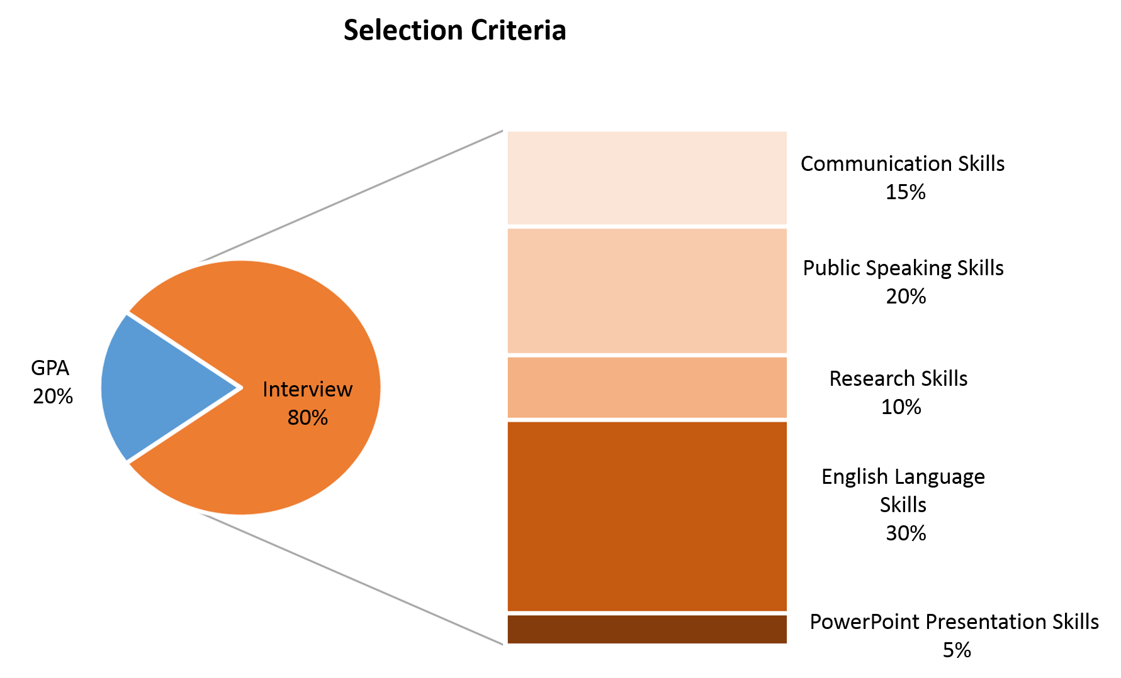
(Weight of Each Criterion)
3.2. Selection Criteria for Incoming Students (from Abroad)
1. Academic Qualification:
a. Applicants must hold an acceptable GPA as determined by their home university.
b. Proficiency in Persian or English at a minimum level of B2 (see the following table):
IELTS | TOEFL iBT | English proficiency level
1.0-2.5 | Not eligible | A1
3.0-4.0 | 0-31 | A2
4.5-5.5 | 32-45 | B1
6.0-6.5 | 46-93 | B2
7.0-8.0 | 94-109 | C1
8.5-9.0 | 110-120 | C2

2. Motivation and Goal-Setting: Applicants must submit a Statement of Purpose (SOP) outlining their academic and research goals, motivation for joining the program, and their rationale for choosing Tehran University of Medical Sciences as the host institution.
3. Social and Cultural Competence: Ability to engage effectively in multicultural environments and willingness to learn from diverse cultural practices.
4. Academic, Research, or Social Background: Evidence of past activities demonstrating the applicant’s commitment and capabilities.
5. Financial and Practical Capability: Submission of documents proving that the student (or sponsor) can cover living and educational expenses during the program.

Article 4. Application Timeline
Tehran University of Medical Sciences will announce opportunities for student exchange programs to students through official communication channels throughout the year, as appropriate.
The registration period for the student exchange program begins upon the submission of applications and continues until the final results are announced, typically lasting approximately one month from the registration deadline. This timeline allows us to adhere to our objective of selecting students fairly and accurately.
The registration process includes the collection of required documents, completion of the application form, and submission of supporting evidence regarding language proficiency and academic qualifications. Following the registration deadline, evaluation and interview procedures will be conducted for eligible students.
Students are required to register for these programs through the announced channels and within the specified timelines, and to submit all required documents to the relevant authorities before the registration deadline.
It should be noted that no late registrations will be accepted after the deadline, and the registration website will be closed. Once the registration period ends, the student selection process will commence, and students will be informed of the scheduled evaluation dates and the announcement of final results.

Article 5. Selection Procedure
The student selection process for exchange programs is conducted in a completely transparent and fair manner. To this end, an interview session is held, attended by the Vice Dean for International Affairs, the Vice Dean for Education, the Vice Dean for Research, and a representative from the Student Committee. The purpose of this interview is to conduct a comprehensive assessment of the applicants’ skills. During the session, students’ communication, presentation, research, and English language skills are thoroughly evaluated.
Committee members assess each student’s abilities and potential based on clearly defined and fair criteria. The final decision regarding student selection for the exchange program is made by considering the interview results alongside other relevant criteria and their respective importance. This process is designed to ensure the quality and success of the exchange programs and to enable students to perform at their best in international environments.

Article 6. Benefits of Participation
Students who register for the student exchange program will benefit from a range of special advantages that enhance both their academic and personal experiences. Some of these benefits include:
- Specialized Classes: To strengthen communication and presentation skills, dedicated classes on Oral Presentation will be offered. These classes help students improve their presentation abilities and perform more effectively in international academic environments.
- Coverage of Travel and Accommodation Costs: The University will cover accommodation expenses for students participating in the exchange program. Students are responsible only for travel tickets and additional living expenses, reducing their financial burden. It is recommended that students assess their financial capability prior to registration to ensure they can afford program-related costs. If the University covers other expenses, reimbursement may take several months.
- Rich Cultural Experience: Participation in this program provides students with a unique opportunity to learn about diverse cultures and lifestyles, contributing to their personal and professional growth.
- International Networking: Students have the opportunity to establish professional connections and international friendships, which may positively influence their future careers.
- Language Skill Enhancement: Studying in a non-Persian-speaking country offers an excellent opportunity to learn or improve the host country’s language, providing an advantage in the global job market.
- Support for Research Projects: Students can utilize the resources and facilities of the host university to advance their research projects effectively.
- Enhancement of Professional Resume: Participation in an international program adds value to students’ resumes and strengthens their global career opportunities.
Given these benefits, all students are encouraged to register for the student exchange program and take advantage of these valuable opportunities to create an unforgettable experience.

Article 7: Responsibilities and Duties
In student exchange programs, four primary stakeholders are involved: 1) Outgoing students, 2) Incoming students, 3) Home university, and 4) Host university.
It is understood that the responsibilities, duties, and rights of each stakeholder are precisely and comprehensively defined in the bilateral agreements and contracts, which are established and implemented specifically for each student exchange program, based on the respective MoU for each program.
With this clarification and in order to provide a general framework, the following outlines the responsibilities of the home university (Tehran University of Medical Sciences), the responsibilities of outgoing students (Iranian students), and the expectations from the host university (outside Iran):
7.1 Responsibilities of the Home University (Tehran University of Medical Sciences)
The home university is responsible for facilitating and enhancing the student exchange process:
- Providing Information and Initial Support:
a. Offering comprehensive and transparent information regarding exchange programs and participation requirements.
b. Guiding students through registration, course selection, and document preparation.
- Administrative Support:
a. Coordinating with the host university for agreements, document submission, and program planning.
b. Issuing official letters required for visa, residence, and financial matters.
- Ensuring Student Preparedness:
a. Conducting pre-departure orientation sessions to familiarize students with host country regulations and culture.
b. Providing guidance and training on interaction in an international environment.
- Protecting Students’ Rights and Providing Support:
a. Monitoring program implementation and offering assistance in case of issues at the host university.
b. Supporting students in emergencies and providing effective communication channels.
- Evaluation and Accreditation:
a. Reviewing and validating the quality of courses and programs offered by the host university.
b. Following up on grade transfer and course accreditation after program completion, subject to the approval of the Vice Dean for Education.
- University Selection and MoU Signing:
a. University selection is based on coordination between the School of Dentistry and the Office of International Affairs.
b. MoU agreements are established in coordination with the School of Dentistry and the International Relations Office of the university.
- Funding Arrangements:
a. All matters regarding funding are determined through coordination between the School of Dentistry and the Office of International Affairs.
- Determining Duration of Exchange:
a. The duration is set in coordination with the Vice Dean for Education.
- Assessment of Exchange Outcomes:
a. University representatives must present feedback on their exchange experience through a presentation or report to the International Council.
7.2 Responsibilities of Outgoing Students (Iranian Students)
Students must fulfill the following responsibilities toward both the home and host universities:
- Preparation and Commitment:
a. Completing all registration steps, submitting required documents, and attending orientation sessions.
b. Demonstrating commitment to the exchange program’s objectives and making optimal use of the academic opportunity.
- Compliance with Host University Rules:
a. Awareness and adherence to the educational and cultural regulations of the host university.
b. Respecting the host country’s culture, customs, and laws.
- Academic Progress:
a. Actively participating in classes and completing assigned tasks at the host university.
b. Providing reports and required information to the home university during the program.
- Maintaining Communication with Home University:
a. Informing the home university of potential issues or changes in the program.
b. Providing feedback on academic and life experiences at the host university to improve future programs.
- Ethical and Professional Conduct:
a. Upholding academic integrity in all studies and research.
b. Avoiding behaviors that violate host university rules or harm the home university’s reputation.
c. Acting as a cultural ambassador for the home university and reflecting its values.
- Reporting and Experience Sharing:
a. Submitting a performance report to the home university after program completion, including academic, research, and cultural achievements.
- Visa and Exit Permit:
a. Students are fully responsible for obtaining the necessary visa and exit permit.
- Financial Management:
a. Students must cover travel ticket costs and understand that any other expenses covered by the university may be reimbursed after several months.
b. Students should assess their financial situation before registration to ensure they can afford living and study expenses during the program.
7.3 Expectations from the Host University (Outside Iran)
The host university is responsible for facilitating the education and living experience of outgoing students:
1. Educational Services:
a. Ensuring courses registered by students are delivered according to the agreed academic plan.
b. Assigning an academic advisor to guide students.
c. Providing access to academic resources, libraries, laboratories, and other facilities.
2. Support for Adaptation and Integration:
a. Conducting orientation sessions introducing university rules, regulations, and local culture.
b. Providing information about available support services, including academic counseling.
3. Accommodation Facilities:
a. Assisting in providing suitable housing, including dormitories or nearby accommodations.
b. Offering guidance on daily life matters such as public transport, healthcare, and city services.
4. Cultural and Social Support:
a. Organizing cultural and social activities to help students adapt and build connections.
b. Supporting students’ participation in clubs and student activities.
5. Certification and Evaluation:
a. Issuing official certificates and transcripts in accordance with the MoU.
b. Collaborating with the home university to facilitate credit transfer.
6. Emergency Support:
a. Providing access to emergency services, including healthcare and security.
b. Assigning a designated point of contact for emergencies.
7. Ensuring Ethical Standards and Equality:
a. Maintaining a discrimination-free and safe environment, ensuring student rights per local and international regulations.
b. Providing formal channels for reporting and promptly addressing student complaints.
8. Cooperation in Program Evaluation and Improvement:
a. Participating in periodic evaluations to improve program quality.
b. Providing regular feedback to the home university regarding student performance and needs.

Article 8: Governing Law
These regulations are subject to the rules and regulations of Tehran University of Medical Sciences. In cases of conflict, university regulations shall prevail.
These regulations consist of 8 articles and 2 notes and have been approved by the Council of Vice Deans for International Affairs and the Board of the School of Dentistry.

